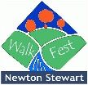 Walker Registration Form
Each walker must complete a form for each walk. The form should be handed to the walk registration clerk.
Route number and name:

Walker details
Name
Address
Mobile phone number
Medical or other issues
Emergency contact information
Name
Address
Telephone

Hill walking and other outdoor pursuits are, by their nature, hazardous pastimes. All reasonable steps have been taken to reduce risk. It is a condition of booking that the participants acknowledge that decisions made by the organisers and walk leaders are final. Children under 16 and vulnerable adults must be accompanied by a responsible adult. By completing this registration form it is deemed that the above terms and our Guidelines for Walkers are accepted, and the organisers cannot be held responsible for any problems that may arise from any relevant undeclared matters. You are also advised to let the walk leaders know if you have any underlying medical condition before leaving.
Whilst Newton Stewart Walking Festival has public liability insurance it will not be responsible for any injury, illness, death or claim of any description whatsoever which results from any of the following:
1. the act(s) and/or omission(s) of any walker; or
2. the act(s) and/or omission(s) of a third party not connected with Newton Stewart Walking Festival and which were unforeseeable or unavoidable;
All walkers are strongly advised to obtain adequate medical insurance to cover them in the event of an accident or illness.
I declare that I have no medical conditions which prevent me from walking this route and I agree to abide by these terms and conditions and Guidelines for Walkers.
Signed: Date:

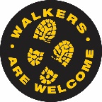
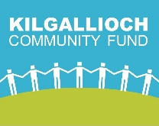
For official use:
Walk Leader:

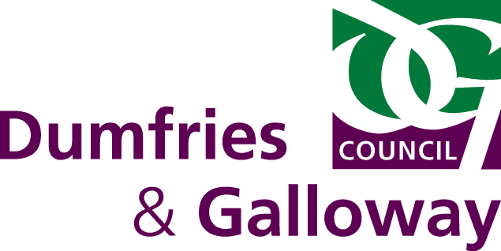
Wigtown Community Shop
The Belted Galloway Visitor Centre

